Experiment 07
Learning Objective: Recover passwords or remove protection from Excel, Word, PDF, Zip, RAR, and Windows accounts. Passware Kit Standard supports 70+ file types.
Tools: Passware Kit Forensic
Theory:
Passware Kit Basic is an easy-to-use tool that recovers passwords for MS Excel and Word documents, Windows accounts, websites, and more.
Features:

70+ file types supported
The software recognizes and recovers passwords for 70+ file types, including MS Word, Excel, and web browsers.

Hardware acceleration
Password recovery is accelerated with NVIDIA and AMD GPUs.

Windows admin password reset
Instantly resets passwords for local Windows accounts and security settings using a bootable USB drive or CD.

Instant results
Instantly recovers or resets many types of passwords.

Passwords history
All recovered passwords are saved and ready to be reused on other files.

Easy to use
Easy step-by-step customization of password recovery settings.
Learning Objective 01: Installation of Passware Kit and Password Recovery with Passware Kit

Installation of Passware kit
If we want to install the Passware kit in windows, we can use the following steps:
Step 1: First, we need to go to the Passware kit basic Website through the https://www.passware.com/kit-basic in the system's internet browser. It is the link where we will download the Passware Kit setup file.

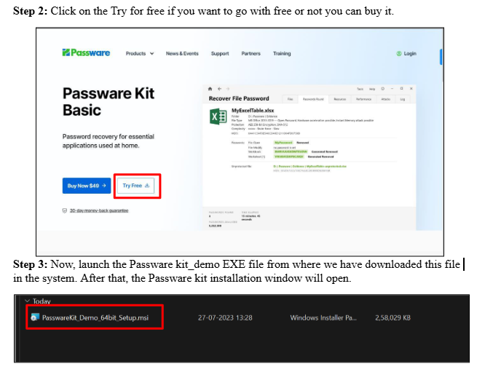
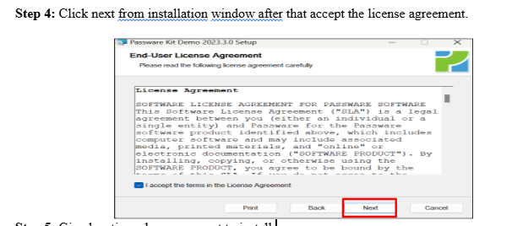

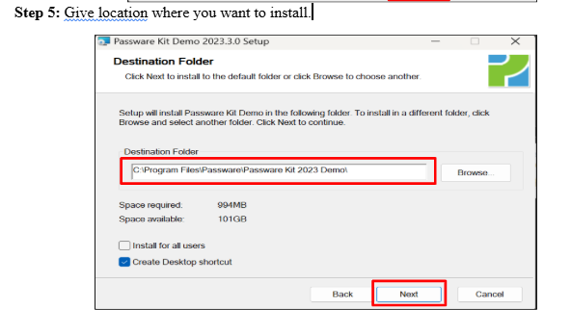

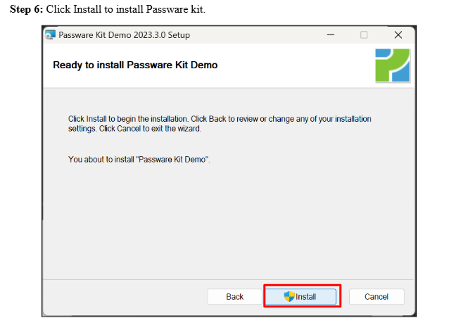
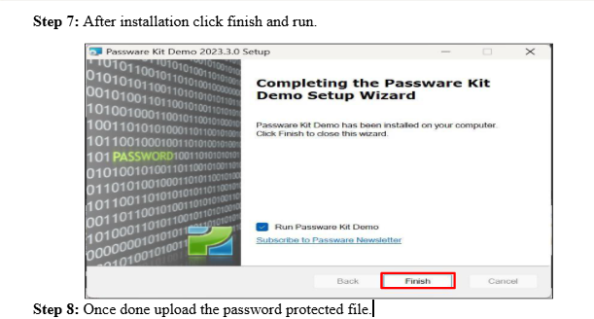

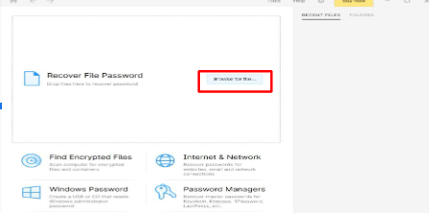

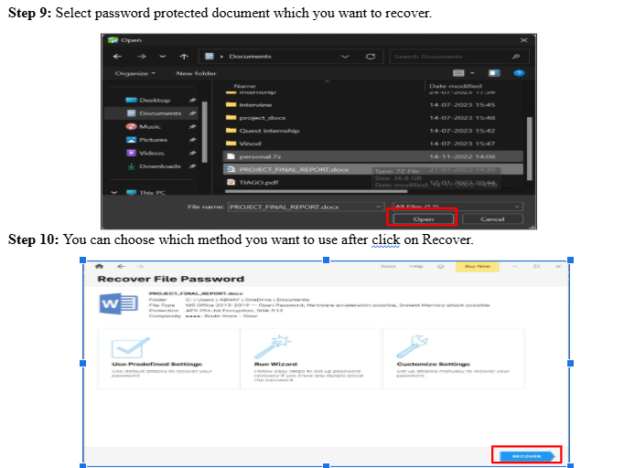
Step 11: After completing the attack if password was recovered it will show as and if you want to know the password you have to buy.

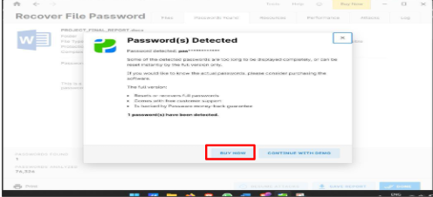

Here I used Run wizard mode .As per your idea you can choose which attack you want to perform if it is Predefined settings it can take more time it has around 15 attacks on it will do one by one and if you are going with Run wizard you can give any details that you know about the password it may be helpful to identify password easily and if you want to go with Brute force attack you can go with that
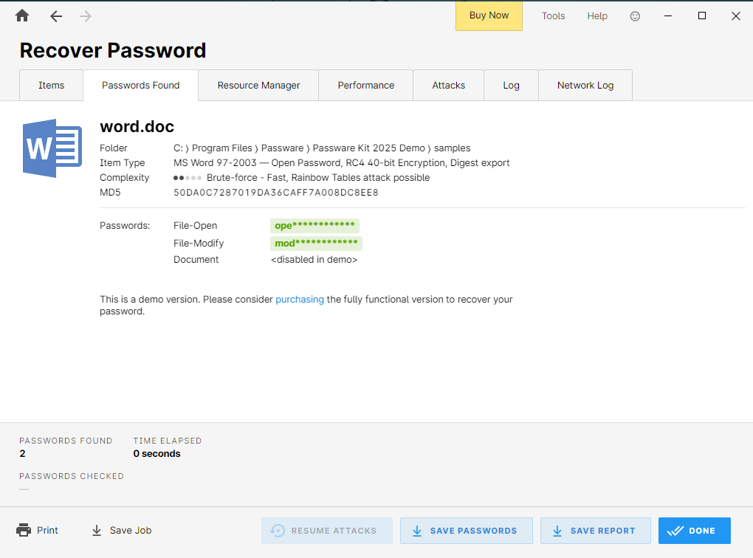
Learning Outcomes: The student should have the ability to LO1: Install the Passware kit
LO2: Can do different attacks to find lost Passwords

Course Outcomes: Upon completion of the course students will be able to understand the concept of Password Cracking.
Conclusion: Through this experiment we learned the concept of finding lost password of files using Passware Kit tool.

For Faculty Use:

Correction Parameters | Formative Assessment [40%] | Timely completion of Practical [40%] | Attendance / Learning Attitude [20%]
Marks Obtained

